**Higher Interest Rates Could Explode Budget Deficits and Our National Debt**

*The National Review* - by Brian Riedl - March 11, 2017

Fiscally responsible deficit reduction is more important now than ever before.

The Federal Reserve is expected to raise the target interest rate next week, continuing its long climb back to traditional levels. While the economic impact of rate hikes is intensely debated, less attention has been focused on the extraordinary impact they will have on federal spending and the national debt.

The short answer is that higher interest rates can cost taxpayers trillions of dollars. The budget outlook is already perilous: After gradually declining since 2010, annual budget deficits are projected by the Congressional Budget Office (CBO) to soar past $1.4 trillion a decade from now, and then keep growing thereafter. And that is the rosy scenario; it assumes no recessions, wars, terrorist attacks, tax cuts, or federal spending expansions.

It also assumes only modest interest rate increases, which is important given that the national debt already sits at $20 trillion and is slated to increase by another $10 trillion over the next decade. CBO estimates that each one-point rise in interest rates adds $1.6 trillion to the ten-year budget deficit — $262 billion of which comes in the tenth year, as costs accelerate. Thus, a four-point interest-rate hike would cost taxpayers $6.4 trillion over the decade, and more than $1 trillion in the tenth year alone — far more than the cost of defense or Medicaid spending.

Fortunately, interest rates have remained low. Because of the Federal Reserve’s policies and the sluggish economy, the average interest rate paid on the ten-year Treasury bond (which is similar to the average interest rate Washington pays on its debt) is currently 2.4 percent, and is projected by CBO to rise to just 3.6 percent in a decade. By comparison, the average interest rate was 10.5 percent in the 1980s and 6.6 percent in the 1990s. Even in the 2000s, which ended with a massive recession that collapsed interest rates, the rate averaged just 4.5 percent.

But now, CBO’s rosy assumption that rates will remain low seems mistaken. First, the Federal Reserve is expected to continue phasing out its policy of keeping interest rates extraordinarily low, meaning rates should normalize over the next few years. Second, interest rates have been constrained by the weak recovery that followed the Great Recession. If the economy eventually returns to its more typical 3.0 to 3.5 percent growth rate, demand for business, auto, and home loans should go up, thus raising interest rates. Finally, and most importantly, the soaring national debt will eventually push interest rates significantly higher, because added demand raises prices.

With the national debt in the process of rising $20 trillion over 20 years, all of Washington’s new borrowing represents a historic increase in the demand for savings, resulting in higher interest rates for the government (as well as for families and businesses). Up until now, the Federal Reserve and the weak economy have counteracted the interest effects of this new debt, saving taxpayers $1.3 trillion in lower national-debt-interest payments since 2009. But as the Federal Reserve tightens its policies, economic growth (hopefully) picks up, and the national debt continues surging, all signs suggest interest rates will be significantly higher down the road.

The effect this has on the budget could be enormous. If interest rates merely return to 1990s levels, the resulting costs would raise the 2027 budget deficit from $1.4 trillion to $2.2 trillion. And if the large increase in government borrowing somehow brings back the 10.5 percent interest rates of the 1980s (unlikely, but not impossible), the annual budget deficit would approach a staggering $3.2 trillion a decade from now. At that point, interest on the debt would cost $2.5 trillion per year, or $17,000 per household — nearly as much as Social Security and Medicare spending combined.

This should give pause to any lawmakers seeking large tax cuts or spending increases. A $1.4 trillion deficit within a decade is risky enough, and deficits of $2 trillion or $3 trillion would be economically catastrophic. Perhaps the CBO is correct that interest rates will remain historically low, but it would be irresponsible to bet the economy on that assumption. Instead, responsible deficit reduction can ensure that future generations are spending their tax dollars on their priorities, rather than making cataclysmic interest payments on earlier expenditures they never voted for.

**National debt nears $20 trillion; Kasich has long warned of troubles**

*The Columbus Dispatch* - By [Bill Bush](mailto:bbush@dispatch.com) – March 6, 2017

Like a street preacher, Alan Viard stood on Capitol Square, taking time out from his job as an Ohio State University economics professor to warn Downtown passers-by that an hour of reckoning was drawing near.

Standing next to a giant digital "clock" ticking upward at $9,500 a second, Viard chatted with the lunchtime crowd about the federal debt. One man, Lynn Brant of Delaware, said the clock "doesn't really mean that much" because most people "do not understand numbers of that magnitude."

The year was 1996, and the clock showed the national debt at $5.3 trillion. Today, the magnitude is even less understandable; the total debt will roll past the $20 trillion milestone any day.

How much cash is that?

• It's 20 million million dollars: a "20" with a "000,000,000,000" after it.

• It's almost $159,000 for each of the 125.8 million U.S. households.

• It's as if each child immediately inherits a $62,000 mortgage at birth from Uncle Sam, without the house.

• If you lined up 20 trillion dollar bills end to end, they would stretch to the moon and back — 4,056 times.

It's a big number, and it's likely to continue to grow under President Donald Trump, who is proposing large tax cuts and large defense-spending increases, said Viard, who left OSU to become an economist with the Federal Reserve Bank of Dallas and now is a resident scholar for the conservative American Enterprise Institute in Washington, D.C.

"Obviously, that combination spells large trouble for the debt," Viard said. "At some point, a crisis will occur. It might be very far off. If it did occur, something would have to be done."

When measured against the nation's expanding gross domestic product, or total annual economic output, the debt was about 105 percent of GDP in the third quarter of last year, according to the Federal Reserve Bank of St. Louis. In 1981, it was barely 30 percent of GDP. Only once has it been higher than today: during World War II, when the nation's economy was transformed to defeat the Axis powers.

"At some point, you can't finance it," said Robert Bixby, executive director of the Concord Coalition, the group that put that debt clock on the Statehouse lawn 21 years ago. "Unfortunately, there's no magic number that you can say, 'If you're over that, it's curtains,' and that makes it difficult for people to get excited about it."

The debt is more than an economic issue; "it's a moral issue," said Gov. John Kasich, who stood with Viard next to the clock that day and continues to travel the country trying to find five more states needed to force a constitutional balanced-budget amendment. He's in a long line of Ohioans from both parties who have tried to rein in the debt.

Kasich fears what will happen when interest rates rise from historic lows. "The problem is, both parties want to spend," he said. "It's just that the conservative party feels guilty when they do it."

Making the debt issue more complex is that just over a quarter of it, $5.53 trillion, is money the government owes itself. That's because, while income taxes have been slashed since the 1980s, payroll taxes earmarked to fund programs such as Social Security and Medicare have increased, collecting more than they needed in advance of the retirement of baby boomers.

Social Security didn't put this cash in a vault somewhere. It lent it to the U.S. Treasury and received bonds, or IOUs, that it placed in trust funds. Social Security is the largest of these intergovernmental creditors, having lent about $2.9 trillion. But that trend is about to reverse, as Social Security cashes in those bonds to pay boomers' benefits.

After 2019, the trust fund "will provide the resources needed to offset Social Security's annual deficits until 2034, when the reserves will be depleted," the Social Security board of trustees said last year. In other words, it's almost time for the government to start paying back the trust funds.

The trust-fund debt "is not insignificant; it's got a different kind of significance," Bixby said. "It's money that the government owes itself. That will need to be paid at some point, but it doesn't flow through the financial market."

At least not yet. Some worry that the intergovernmental debt will be repaid by issuing new public debt to banks, insurance companies, foreign governments and the guys with the limitless checking account at the Federal Reserve.

The Treasury calls the non-trust-fund portion the "debt held by the public," which stands at about $14.4 trillion. It is expected to top $25 trillion by 2027, according to the Congressional Budget Office.

The debt has been a hot-button issue since the nation's early days.

"There does not exist an engine so corruptive of the government and so demoralizing of the nation as a public debt," Thomas Jefferson wrote in 1821. "It will bring on us more ruin at home than all the enemies from abroad against whom this army and navy are to protect us."

Alexander Hamilton, of recent Broadway fame, held the view that the debt could be a good thing, used to bolster federal authority. The debt, if "not excessive, will be to us a national blessing," Hamilton said.

Ohio's leaders have long been wary of Hamilton's promise. During the 1970s and early '80s, they believed that government deficits were contributing to despised double-digit inflation rates.

"There may be times when a budget deficit is necessary to stimulate the economy," Rep. Chalmers P. Wylie, a Republican, wrote in a Dispatch op-ed in 1978, "but it should not be a way of life."

In 1980, as a Republican state senator from Westerville, Kasich sponsored a resolution calling on Congress to hold a constitutional convention on an anti-deficit amendment. "We must bind the rascals with the chains of the Constitution," Kasich said. At the time, 30 states had approved similar resolutions, four short of the number required for a convention.

Ohio Gov. James A. Rhodes in 1982 blamed skyrocketing interest rates on the federal debt, and the Republican called on Congress to "raise taxes and earmark it for the national debt," which had just topped its first trillion.

U.S. Sen. John Glenn, the Ohio Democrat, voted with constitutional-amendment supporters at times, but he rejected proposed amendments he thought were not flexible enough during emergencies.

In 1985, then-Ohio Secretary of State Sherrod Brown was traveling around the state inviting mayors, businesspeople and others to play "Debt-Busters," a game in which participants would have to make the hard choices to balance the federal budget.

In 1992, a high-school-age caller to C-SPAN asked Brown, who had become a congressman, what was the greatest threat to the nation.

"The greatest threat is what we're leaving your generation," the Democrat responded, citing the combination of a "massive national debt" and crumbling infrastructure. The debt stood then at just over $4.1 trillion.

In 1995, the U.S. Senate fell two votes shy of sending a balanced-budget amendment to the states for ratification. The major disagreement: how to treat those tricky trust funds. The Los Angeles Times reported that the amendment would have passed "if the GOP had added language explicitly barring the use of the Social Security trust-fund surplus to help reduce the federal budget deficit."

"It's not honest to do it this way," Sen. Byron Dorgan, D-N.D., said in explaining his no vote, which helped sink the deal.

But Congress and President Bill Clinton eventually balanced the budget without changing the Constitution; from 1998 to 2001, the federal government ran surpluses, the only time that has been achieved since 1969.

Kasich warned that the surpluses wouldn't continue without amending the Constitution, and he was right: The "rascals" slipped their chains again in 2002. And by the time of the 2008 Wall Street crash and bank bailout, the debt stood at about $9.5 trillion, or 62 percent of GDP.

Since that crisis, which launched the Great Recession, the debt roughly doubled in less than a decade during the presidency of Barack Obama.

That's the case even though the interest payments, which the Treasury says totaled $436.7 billion last year (about a third of which went to the trust funds), are actually less than 2008's $451.2 billion. January's average interest rate on the debt was 2.24 percent, down from almost 5 percent in 2008.

Congress can thank the Federal Reserve, which in 2008 pushed short-term rates down to almost zero and held them there for years while tripling its federal-debt holdings to about $2.46 trillion — 17 percent of all the debt held by the public, according to the Federal Reserve Bank of St. Louis website.

If the Fed starts selling those bonds to raise interest rates, Viard said, the free lunch could end in a big, unpredictable way.

"It's like if termites are eating away at your house," he said. "You should take some action now."

**How Rising US Debt Impacts the Economy?**

*The Market Realist* - By Mary Sadler - March 7, 2017

**Rising US debt**

In a February 24, 2017, [*Wall Street Week*](http://video.foxbusiness.com/v/5336733272001/?#sp=show-clips) interview with Fox Business Network, David Asman and Cheryl Casone talked about America’s mounting debt. They shared their views on the increasing US debt and its impact on the economy.

Also in the interview, Steve Mnuchin, United States Secretary of the Treasury, said he considered the US debt a long-term issue compared to the focus on US economic development.

**Federal debt and economic growth**

US growth ([SPY](http://marketrealist.com/quote-page/spy/)) ([IVV](http://marketrealist.com/quote-page/ivv/)) in the fourth quarter of 2016 was supported by moderate growth in consumer spending and a build-up in inventories. The national debt has risen significantly due to rising deficits. The gross federal debt at the end of 2016 was $19.5 trillion. The total debt for 2017 is estimated at more than $20.0 trillion, according to the [2017 Federal budget](http://budget.house.gov/fy2017/).

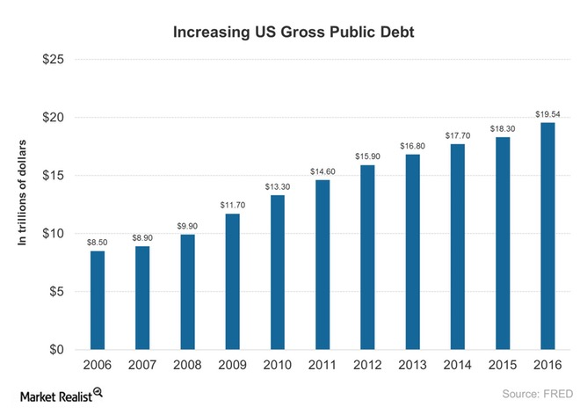

**Why is the US national debt rising?**

As you can see in the above graph, the national debt over ten years has risen more than 100% due to consistent annual budget deficits. A deficit generally arises for a number of reasons, including war, economic recession, and inflation, when government spending outpaces revenues.

**Economic impact of rising debt**

Government spending from higher debt benefits the people in the short term since it boosts economic activity. But in the long term, if economic output doesn’t support increasing debt, it can lead to a spiral of more debt to service government spending. Higher debt may result in higher interest rates and higher interest payments for the government in the long run, thus slowing down economic activity.

Higher interest rates for domestic investments such as mortgages, credit cards, consumer loans, and business loans will likely dampen the credit demand in the banking sector. Some of the big banks in the sector include Bank of America ([BAC](http://marketrealist.com/quote-page/bac/)), Wells Fargo ([WFC](http://marketrealist.com/quote-page/wfc/)), Citigroup (C), and JPMorgan Chase ([JPM](http://marketrealist.com/quote-page/jpm/)).

# **How the Budget Deficit Is Increasing US Debt?**

**Budget deficit**

The national debt is used to fund past budget deficits. In 2016, the budget deficit rose to $587.0 million, a 30.0% rise from 2015. Also, the deficit as a percentage of GDP rose 3.2 % in 2016 compared to 2.4% in 2015. The debt held by the public reached 77.0% of GDP in 2016, making it the highest since 1950.

The budget deficit compares federal government spending to its revenues or receipts. The deficit has a large-scale impact on the national debt when the federal government continuously borrows to fund its deficit. The US budget deficit is estimated at $441.0 billion for 2017. Let’s take a look at the budget deficit over the years.

**US budget deficit in the past 10 years**

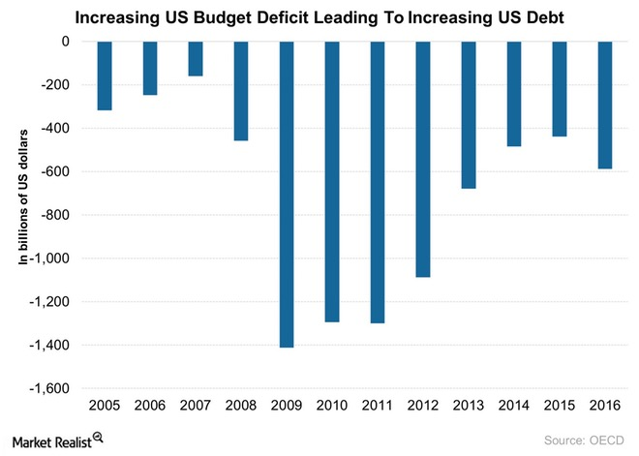The mortgage crisis that began in December 2007 resulted in massive economic and financial challenges for the United States. It led to more deficit in 2008. The deficit continued to rise in 2009 to $1.4 trillion when the federal government took an aggressive step to attempt to restore the health of the economy.

As you can see in the above graph, the deficit fell slightly in 2010 due to improvements in economic growth. Since 2012, there’s been a continuous decrease in the deficit as the economy showed some recovery. However, the deficit increased $587.0 billion in 2016, and it’s expected to fall below 3.0% of GDP in 2017.

The Congressional Budget Office estimates that the budget deficit will fall in 2017 to 2.9% of GDP and in 2018 to 2.4% of GDP. The fall in the deficit is likely to help reduce the debt level.

**Economic impact**

The rising deficit and growing debt are likely to affect the bond markets ([IEF](http://marketrealist.com/quote-page/ief/)) ([TLH](http://marketrealist.com/quote-page/tlh/)). The spiral of debt can lead to rising borrowing costs for non-government issuers, thus increasing yields.

Utilities tend to have high debt loads, making them vulnerable to interest rates. Utility companies include Duke Energy ([DUK](http://marketrealist.com/quote-page/duk/)), NextEra Energy ([NEE](http://marketrealist.com/quote-page/nee/)), Southern Company ([SO](http://marketrealist.com/quote-page/so/)), and Dominion Resources (D).

**How Big Is the US Debt Compared to Other Nations?**

**US debt compared to its GDP**

The US debt rose to $19.5 trillion in 2016, a rise of $1.4 trillion compared to 2015. The total debt, which includes intragovernmental debt, rose from $5.1 trillion to $5.5 trillion, and debt held by the public rose about $1.0 trillion to $14.2 trillion.

Let’s look now at the debt levels for other nations compared to their GDPs. The debt-to-GDP ratio compares a country’s debt to its total economic output, measured in terms of gross domestic product.

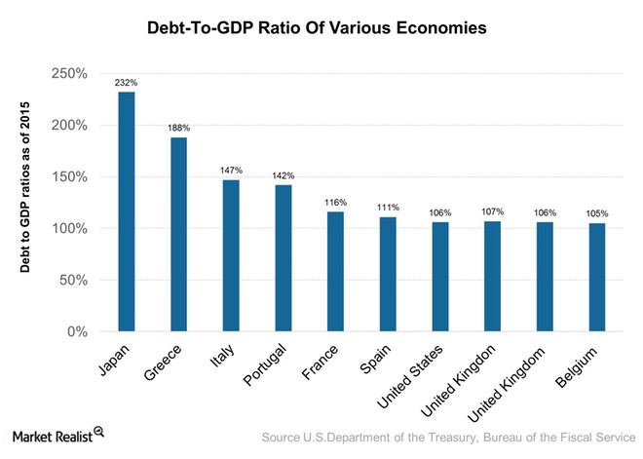

**US debt compared to other nations**

The federal debt-to-GDP ratio is dependent on the nation’s fiscal policies and overall economic condition. The United States had a debt-to-GDP ratio of 106.0% as of 2015. As you can see in the above graph, Japan leads the nations with its rising debt-to-GDP ratio. The United States is in seventh place, according to data provided by the OECD (Organisation for Economic Co-operation and Development) as of 2015.

Japan’s estimated gross debt is about twice its GDP held by households and the central bank. If you compare Japan’s debt to the US debt, Japan’s debt is mostly held by its citizens, about 90.0%. However, the US debt is a mixed bag of external creditors and its people. Greece, unlike Japan and the United States, is currently in a vulnerable position since it can print its currency to finance its debt to avoid defaulting on its loans.

**Impact of rising deficit**

Government debt increases as the demand for credit increases to fund the increasing level of deficits. The cost of borrowing tends to rise in the spiral of rising debt. Higher interest rates make investments in equipment, stock, and other capital goods in the private sector expensive. Big private sector companies tend to be under pressure due to the rising interest rate environment.